Social Emotional Learning Resources for Parents
10 Ways Parents Can Bring Social-Emotional Learning Home
https://www.edsurge.com/news/2020-04-02-10-ways-parents-can-bring-social-emotional-learning-home
SOCIAL AND EMOTIONAL LEARNING ACTIVITIES FOR FAMILIES AND EDUCATORS
https://www.k12.wa.us/sites/default/files/public/studentsupport/sel/pubdocs/SEL%20Parent%20and%20Educator%20Activities.pdf
Social and Emotional Learning: Strategies for Parents
https://www.edutopia.org/social-emotional-learning-parent-resources
Schools, Families, and Social and Emotional Learning: Ideas and Tools for Working with Parents and Families
https://casel.s3.us-east-2.amazonaws.com/schools-families-and-social-and-emotional-learning.pdf
10+ Social Emotional Activities for Home
https://www.thepathway2success.com/10-sel-activities-for-home/
5 Easy Social Emotional Learning Activities for Kids to do at Home
https://betterkids.education/blog/5-easy-social-emotional-learning-activities-for-kids-to-do-at-home
7 Tips for Practicing SEL at Home
https://go.panoramaed.com/hubfs/7%20Tips%20for%20Practicing%20SEL%20at%20Home.pdf
Building Social and Emotional Skills at Home
https://www.naeyc.org/our-work/families/building-social-emotional-skills-at-home
Social Emotional Learning Toolkit: Family Engagement
https://www.movethisworld.com/wp-content/uploads/2020/03/Social-Emotional-Learning-Family-Toolkit.pdf
America’s Promise
The mission of this site is to develop a deep understanding of the conditions necessary for young people to succeed in school and life. The Center for Promise produces rigorous mixed methods research for both academic and non-academic audiences. Its unique value as a research institute is its dedication to youth voice, whether by highlighting the voices and views of young people or working with youth to develop and implement research methods to study the issues affecting their lives.
https://www.americaspromise.org/

6 Ways Parents Can Bring Social-Emotional Learning Home
https://www.schoology.com/blog/6-ways-parents-can-bring-social-emotional-learning-home
Parent Social Emotional Learning Resources from CASEL (the Collaborative for Academic, Social and Emotional Learning)
The website is a curated list of resources, such as blogs, videos, webpages, articles and book chapters, etc. selected by CASEL staff that focuses on the role of parents and parenting in social and emotional learning.
https://casel.org/systemic-implementation/sel-with-families-caregivers/
Confident parents confident kids
This site is focused on skills promotion and prevention, not on problems. Problems will be addressed but in a way that uses the situation as a "teachable moment" for the child and the whole family. In short, suggestions are meant to be used right away and easily to support you in optimizing your child's social and emotional learning AND family's connectedness.
https://www.fordham.edu/graduate-school-of-education/centers-and-institutes/the-center-for-educational-partnerships/nysnyc-regional-bilingual-education-resource-network/social-emotional-learning-parents-resources/
confident parents confident kids
https://confidentparentsconfidentkids.org/2018/11/08/parents-hopes-for-confident-happy-kids-are-realized-through-social-and-emotional-skills/
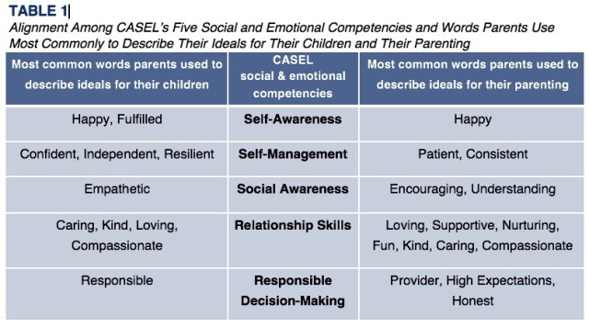

PBS for Kids
This site provides parents/families with an array of activities for children ages 2-8 supporting social-emotional and academic growth. Information about how to support children through the Corona crisis is also addressed.
https://www.pbs.org/parents/
Resources for Parents of K-12 Students
Activities designed for parents/guardians to do with their children to strengthen their social and emotional learning skills.
https://sel.ed.sc.gov/parents/parent-files/sel-learning-activities/

