SSS IMPACT AWARD
Deadline for Submission October 20, 2021 at 5:00pm
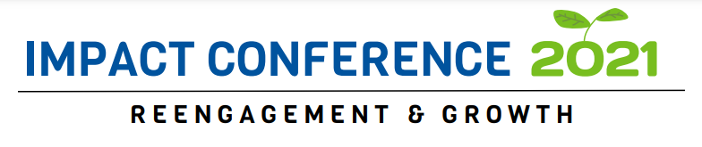

The Student Impact Award was established to recognize exemplary performance by individuals within the Communities In Schools network in North Carolina, who have demonstrated excellence in their work with students, allowing them to succeed in school and in life. The award is open to Student Support Specialists, Site Coordinators and other direct service staff in any capacity, identified by their supervisors and peers as having consistently excelled in their role, and who have demonstrated integrity and a strong commitment to the mission and values of Communities In Schools.
An award is given for each of the following categories:
* Student Support Specialist, Site Coordinator or other direct service staff delivering the CIS Model within an elementary school setting.
* Student Support Specialist, Site Coordinator or other direct service staff delivering the CIS Model within a middle school setting.
* Student Support Specialist, Site Coordinator or other direct service staff delivering the CIS Model within a high school setting.
* Staff delivering programs directly to students but outside the traditional school-based CIS model of Integrated Student Supports. One award will be given for programming outside the model to include, JNCG, R2R, afterschool or any other direct services. The awards recognize exemplary work in their program, as well as their partnership within the CIS network to ensure a commitment to the mission and values of Communities In Schools.

How to Nominate:
- You may only nominate an individual in a single category, even though they may serve multiple grade levels. Choose the category that best exemplifies the success of the nominee.
- Any current staff member within the CIS network in North Carolina, that meets the criteria above, for the category selected, and is a current employee at the time of nomination is eligible for consideration of the award if they work at least half-time (20 hours/week) and have a minimum of two years employment with CIS.
- Any current staff member within the CIS network in North Carolina may nominate a peer or staff member, provided they meet the criteria contained within these instructions. This includes repositioned staff, where there is an agreement with the school/district for this person to work under the mission of CIS and supervised by a CIS employee.
- Information contained in the nomination may be used during the presentation of the award winner and is not considered confidential.
- Previous award winners are ineligible for a period of at least five years from the time they receive the award. At that time they may again be nominated.
- Nominees who were not awarded the Student Impact Award may be nominated again the following year.
Criteria for Consideration:
- Impact Award recipients will have made a significant impact on the Communities In Schools network in North Carolina and ultimately our students and families through outstanding dedication, exceptional practice and performance, excellent service to students, and ingenuity, as demonstrated by the following:
  - Exemplary Achievement and Performance
  - Consistently and substantially exceeds the expectations of the position, performing at a level above and beyond normal job requirements and expectations
  - Has made important and significant contributions in their area of service
  - Contributes and demonstrates a commitment to the Communities In Schools mission and core values
  - Consistently and substantially demonstrates an ability and willingness to work positively, respectfully, and effectively with others
  - Demonstrates the ability and willingness to manage changes in work priorities, procedures, practice, and organization
  - Demonstrates exceptional ability to foster collaboration, communication, and cooperation among colleagues, schools, students and families, partners, their local community and other members of the CIS of North Carolina network.
  - Shows Diversity, Equity and Inclusion awareness and understanding within their work.
  - Developmental Relationships is used within work
  - Current CISDM Data

Nominee's Name:

Nominee's Affiliate:

Nominated by:
Name and email address:
Nomination Narrative
- Describe how the nominee has demonstrated one or more of the criteria listed above, using specific examples of how the individual demonstrates each noted characteristic. Please use as much detail as possible.

Required Documentation Attachments*
Please attach the following:
*minimum of two letters of support, not from nominator
*any essential documents that provide evidence of the nominee's excellence

Return nomination and any required attachments to Heather Fogle hfogle@cisnc.org by October 20, 2021.

