Affiliate Leadership Update
Year: | 1st Quarter 2nd Quarter 3rd Quarter 4th Quarter
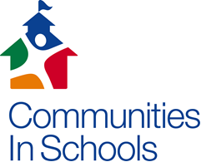
School Name: | Student Support Specialist: | Date: | Report Submitted to:
Members of School Support Team:
Dates of Meetings with School Leadership:
Dates of School Support Team Meetings:

School Support Progress
School Support Goal |  | Interventions/Supports Planned | Was it Provided?  (Yes/No) | Students Served by Tier |  |  | Status of Aligned Metric (Progressing/Maintaining/  Declined)
 |  |  |  | T1 | T2 | T3
A |  | 1.  2.
B |  | 1.  2.
C |  | 1.  2.
P |  | 1.  2.
O |  | 1.  2.
Concerns/Challenges:

Case Managed Student Progress
Student Goal | # of Students with Goal | % Making Progress/Met Goal | Concerns/Challenges | Additional Support Needed
Improve/Maintain Attendance
Improve/Maintain Behavior
Improve/Maintain Coursework
Improve/Maintain Parent Engagement
Other
No Goal Assigned

Any Challenges/Issues with School Leadership/School Support Team/School Staff/Parents?

Signatures Needed: | Student Support Specialist | Executive/Program Director

CISNC 2016

