Monitoring School Progress and Adjusting the School Support Plan
1. From the toolbar on the left, select Site Coordinator Dashboard.
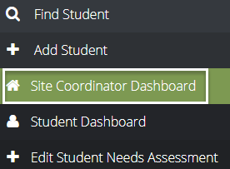
2. Select School Needs Assessment & Support Planning from the School Activities pane. Click the gear icon and then School Needs Assessment Data
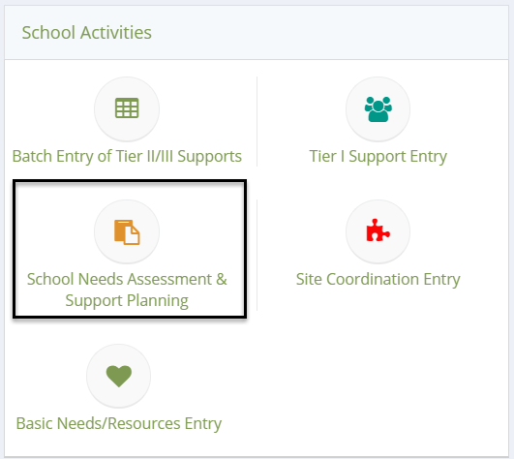
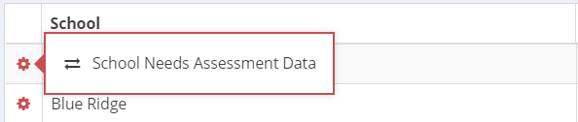

3. From the School Needs Assessment landing page, click the Progress Monitoring button.
4. After clicking Progress Monitoring, you should see the school-wide goal and associated metric. Remember, all goals selected in the school support plan will appear in this table and should be monitored. From the gear icon, select Progress Monitoring.
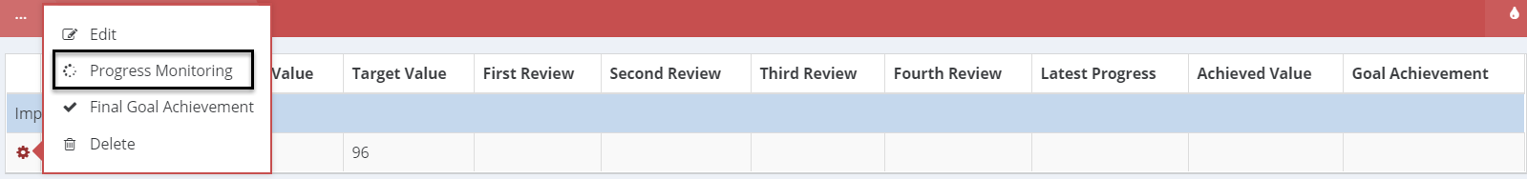

5. Once on the Progress Monitoring, there are four areas to complete:
(A) Review Type: is it the 1st, 2nd, 3rd, or 4th grading period?
(B) Value: Based on the metric you have selected to monitor, what is its value for the grading period (e.g., 95% attendance rate for the 1st grading period)?
(C) Provided Tier One Supports Related to This Goal?: Was a tier 1 support provided that focused on this goal in the 1st grading period?
(D) Progress Towards Goal: Did the school progress or decline on this metric?
(E) Notes: Is there any information related to progress monitoring you would like to add?

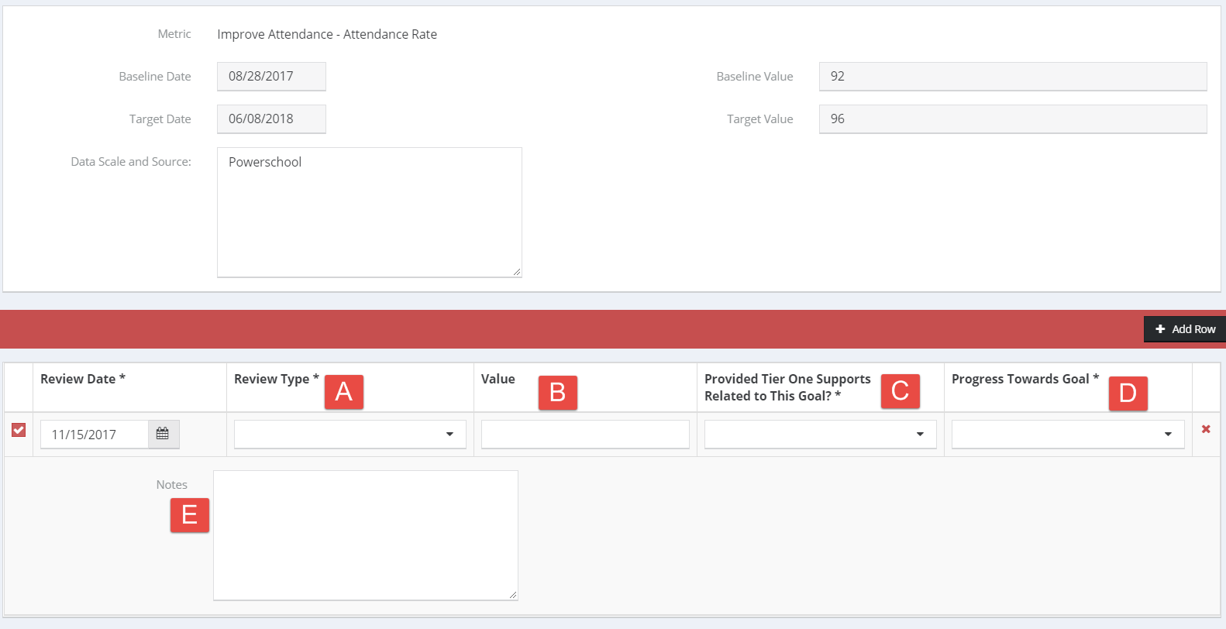

Monitoring Student Progress and Adjusting the Student Support Plan
1. From the toolbar on the left, select Student Dashboard.
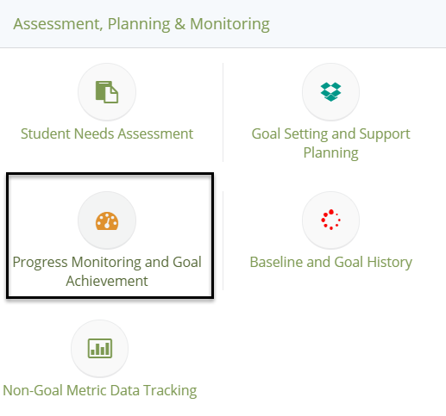
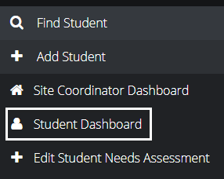

2. Once on the Student Dashboard, scroll down. Select Progress Monitoring and Goal Achievement from the Assessment, Planning & Monitoring pane.

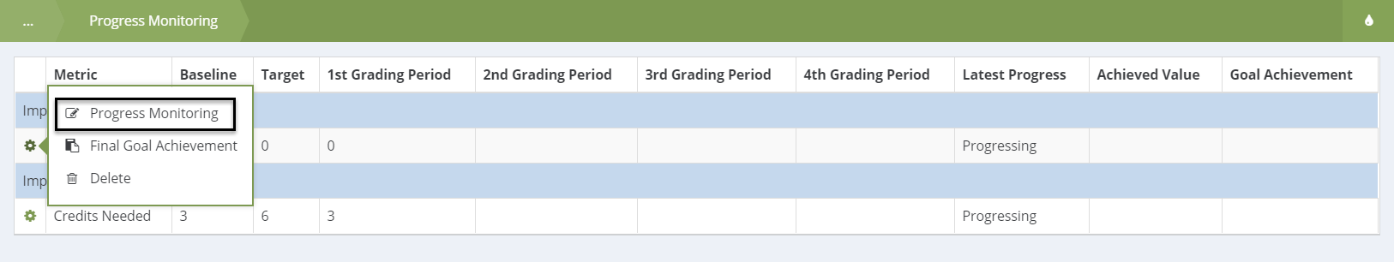
3. From the Progress Monitoring landing page, click the gear icon under the goal for which you want to monitor. Remember, all goals selected in the student support plan will appear in this table and should be monitored. From the gear icon, select Progress Monitoring.

4. Once on the Progress Monitoring, there are four areas to complete:
(A) Review Type: is it the 1st, 2nd, 3rd, or 4th grading period?
(B) Progress Against Goal: Did the student progress or decline?
(C) Metric Value: Based on the metric you have selected to monitor, what is its value for the grading period (e.g., 5 tardies for the 1st grading period)?
(D) Did you adjust the Student Support Plan as a result of your monitoring?
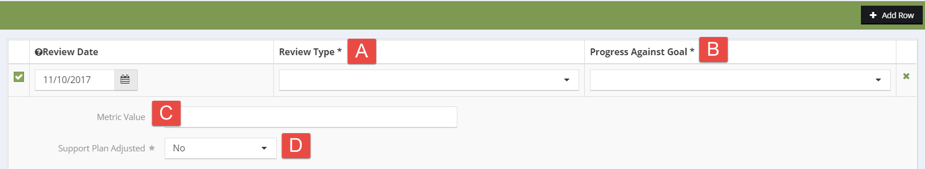

Adjusting the Student Support Plan
From the Student Dashboard, click the Goal Setting & Support Planning button. You can edit supports by clicking the View Planned Supports button, adding the new support(s), and saving.

